**Monitoring temperature in fridges and freezers using sensors**

**Normal behavior:**

* When the fridge/freezer door is closed, the temperature variation is minimal (steady state)
* When the door is opened, the temperature fluctuates more significantly because external air mixes with the internal environment

**Problem:**

* Some appliances exhibit abnormally high temperature variations (even when the door is closed). This behavior is unusual and might indicate a potential issue with the fridge/freezer or the sensor itself

**Possible Causes of the Abnormal Behavior:**

1. Sensor Placement Issue:

* If the sensor is not placed properly (e.g., near the door or not in the center of the appliance), it may experience higher fluctuations caused by small airflow changes or intermittent exposure to external air.
* It might also be placed near a heat source (e.g., a light bulb or a heating coil inside the appliance).

1. Malfunctioning Appliance:

* The appliance itself might not be functioning properly.
* Its cooling mechanism (e.g., compressor or thermostat) could be faulty, leading to uneven temperature regulation
* The door might not be sealing properly, allowing warm external air to leak in, even when the door is closed.

1. Frequent Door Openings:

* If the door is being opened and closed repeatedly (e.g., in high-traffic areas), the temperature inside may fluctuate more frequently than expected.
* This could also happen if someone partially closes the door but doesn't secure it fully.

1. External Environmental Factors:

* If the appliance is placed in a location with high ambient temperature or near a heat source (e.g., an oven, direct sunlight, or a warm room), it may struggle to maintain a stable internal temperature.

**Optimal Range of Compressors for Temperature**

1. **Freezer Optimal Temperature Range**

* Optimal range = -20°C to -15°C: Indicators of a Good Freezer
* Amplitude of oscillations: ~3–5°C
* broad range like -25°C to -10°C indicates irregular compressor behavior or poor insulation
* warm range like -10°C to -5°C suggests a faulty compressor or door sealing issues

1. **Fridge Optimal Temperature Range**

* Optimal range = 1°C to 6°C: Indicators of a Good Fridge
* Amplitude of oscillations: ~3–5°C
* broad range like 0°C to 10°C indicates irregular compressor behavior or poor insulation
* warm range like 5°C to 12°C suggests a faulty compressor or thermostat failure

**An example of three different kinds of freezers and their condition (Børnesymfonien)**

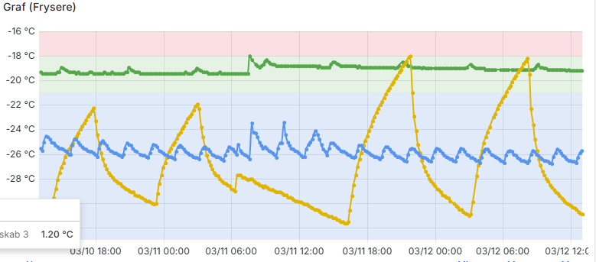

**The green freezer** seems to be in **good working condition**, maintaining a stable temperature within the expected range.

**The blue freezer** is operating **colder than necessary** and **shows moderate oscillations**, which may indicate inefficiency or a **minor issue with its thermostat or compressor**.

**The yellow freezer** has significant and **irregular fluctuations**, potentially caused by **mechanical issues** (**e.g., compressor, defrost system) or operational factors (like frequent door openings**).